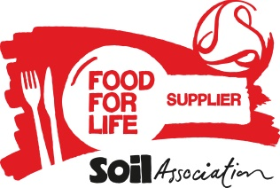
Food for Life Supplier Declaration - Meat

In order to meet Food for Life Served Here standards, all meat served on Catering Mark menus must be from farms satisfying UK welfare standards and farm assured by one of the welfare schemes detailed below.

Section 1 - Details of meat supplied

Name of Caterer supplied:
Please give details of the farm level assurance of the meat and meat products you are supplying:

Meat and Meat Product  (e.g. beef mince [reference code], lamb joints [code], premium pork loin [code], poultry [code], bacon [code], sausage [code], burgers [code] and cooked meat) [code]) | 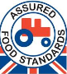  Red Tractor | 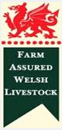  Farm Assured Welsh Livestock | 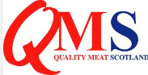  Quality Meat Scotland | 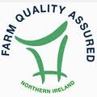  FQAS | 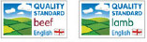  Quality Standard Mark (Beef & Lamb) |   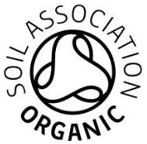  Organic | 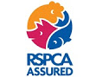  RSPCA Assured | Other (see Standard 1.2 for accepted schemes) | In addition, the product is *Free Range

*Free-range, outdoor reared or outdoor bred products must also be accredited by to one of the schemes detailed.

Section 2 – Declaration
- I declare that I hold evidence to support the assurance claims specified above.
- I undertake to produce adequate documentation to demonstrate that all such products meet the above criteria, if requested.
- Note: Soil Association Certification Ltd reserves the right to contact members of the supply chain and Farm Assurance companies regarding any Farm Assurance claims made.

Name : | Signed: I have completed this form electronically and am in agreement
Organisation: | Date:

Please see the Food for Life Served Here handbook (Standard 1.2) for further details https://www.soilassociation.org/certification/catering/business-support-for-award-holders/standards/ or contact 0117 914 2406 if you have any questions.

